Name:
Module 05 Test
Questions |  |  |  | Please write answers to each question in this column unless otherwise indicated.
- A guy wire for a pole for a tennis net makes an angle 62˚ with the ground.  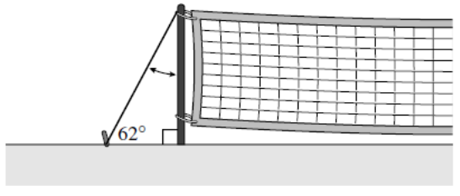  What is the measure of the angle between the wire and the pole? |  |  |  | 20⁰
- Find the value of x.  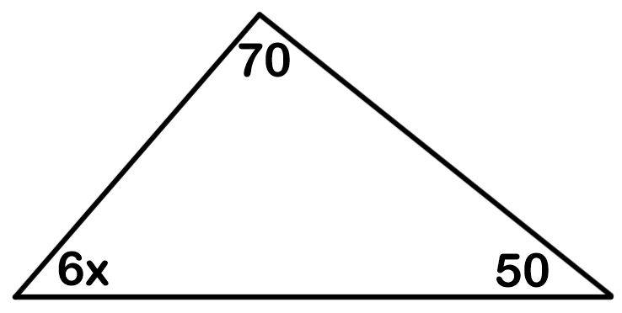 |  |  |  | X=10
- Find the measure of angle A.  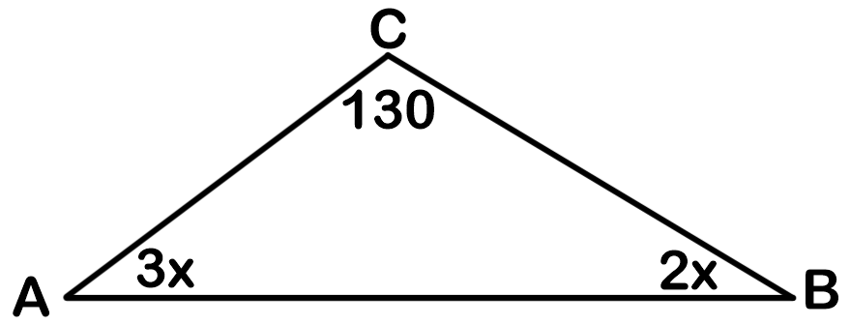 |  |  |  | X=10
- Find the value of x.  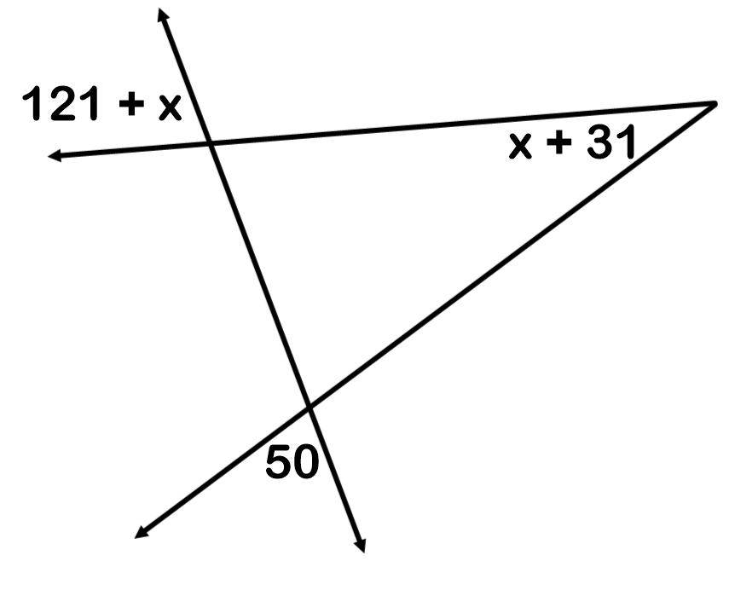 |  |  |  | Undefined
- Find the value of x and y.  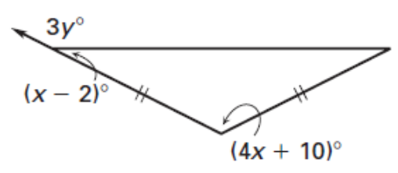 |  |  |  | X = 29⁰  Y = 51⁰
- What is the perimeter?  3x - 5  11x - 12  3x + 36 |  |  |  | P = 121
- What is the measure of angle A?  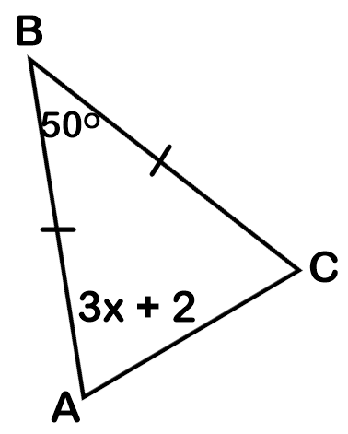 |  |  |  | A = 65⁰
- If the perimeter is 52, what is the length of DF?  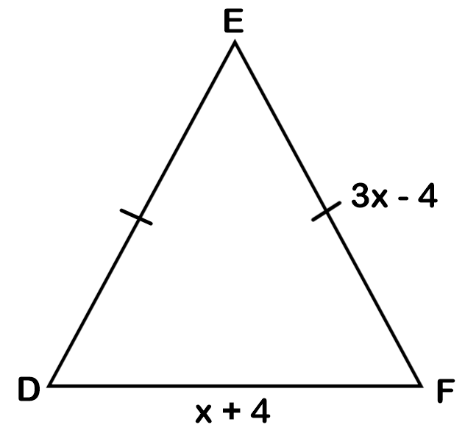 |  |  |  | DF = 12
- Find the value of x.  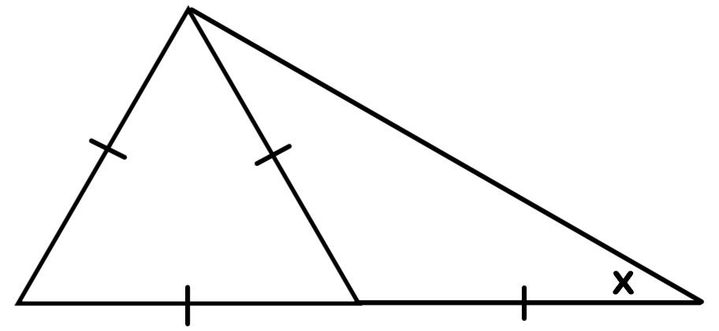 |  |  |  | X = 30⁰
- What is the length of ST?  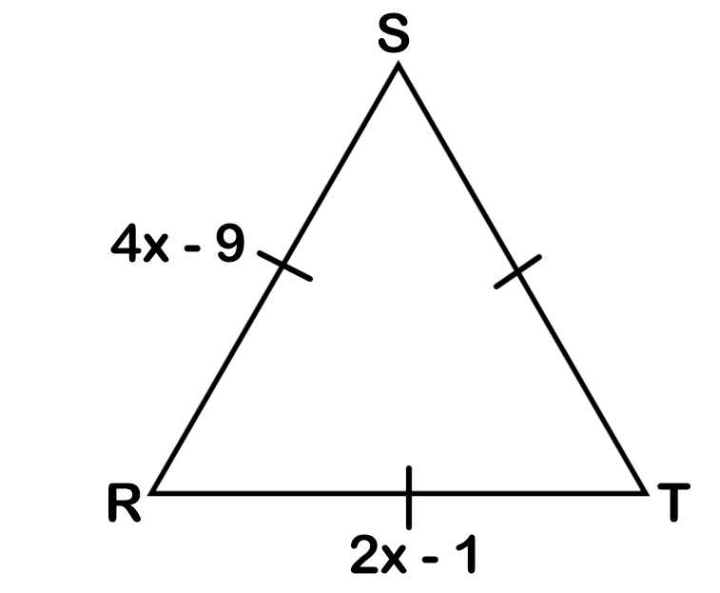 |  |  |  | ST = 7
- Identify AB as a midsegment, median, altitude, angle bisector, or perpendicular bisector.
A  B | A  B  Perpendicular bisector ____________ | A  B  median | B  A  Angle bisector  __________________ |  | A  B  Altitude  __________________

